ESSENTIALS OF ARTIFICIAL INTELLIGENCE
INDIVIDUAL CONTRIBUTION SHEET
Student Name: | Yasith Nirmal Peiris | Registration No.: | D/BSE/25/0018
Degree / Intake: | Information Technology / 2024 | Group No.: | 44
Project Title: | Scam Sentry: An Intelligent Fake Job Advertisement Detection System
GitHub Username: | yasithnirmal88 | Live Demo: | scam-sentry-1.onrender.com
Executive Contribution Summary
As the lead backend architect, risk engine designer, security engineer, and test author for Scam Sentry, I designed and developed the core intelligence and infrastructure of the platform (50 commits, >18,300 lines added across the project). I engineered the deterministic multi-tier Risk Engine featuring 18 graded indicators (C1–L3), first-match-wins decision logic, and consistency safety nets to guarantee Critical threat dominance over probabilistic ML scores. I developed the pluggable 10-source job-board scanner, background daemon scheduler, and dual-backend storage facade supporting SQLite and PostgreSQL. Furthermore, I authored the complete 403-test automated quality assurance suite, established the CI/CD pipeline, hardened API security against brute-force and scraping abuse, and implemented the CV relevance matching and bare-city geographic resolution pipelines. The live system is deployed at https://scam-sentry-1.onrender.com/.
Detailed Technical Contributions
No. | Technical Area | My Specific Contribution | Tools & AI Techniques | Evidence & Deliverables
1 | Deterministic Risk Engine & Indicators | Designed and implemented the core rule-based Risk Engine with 18 graded indicators across 4 severity tiers (C1–C4 Critical, H1–H6 High, M1–M5 Medium, L1–L3 Low). Implemented first-match-wins arbitration rules and V1–V3 consistency safety nets so Critical fraud indicators (advance fee, sensitive identity requests) can never be averaged away by ML probability scores. | Rule-based Reasoning, Python, Regex Engine, Deterministic Decision Trees | risk/indicators.py, risk/engine.py, risk/consistency.py (Commits fe0abfd, 4cec4a1, 0c191b8); tests/test_engine.py 17 passed. See Fig. 1 & Fig. 2.
2 | Responsible AI Language Discipline | Engineered ethical language discipline sanitization preventing defamatory allegations (e.g., claiming a listing is “fake” or “a scam”). Generated forensic, evidence-backed red flag statements coupled with legitimate alternative business explanations, ensuring academic and legal safety. | Deterministic Lexical Sweep, Content Moderation, NLP Sanitization | risk/language.py (Commits 4cec4a1, 0c191b8); tests/test_language.py 5 passed.
3 | Job Board Scanner Framework & Ingestion | Built an extensible, pluggable job ingestion architecture (BaseScanner interface) and implemented connectors for 10 public job boards (RemoteOK, Remotive, Arbeitnow, Jobicy, Himalayas, Working Nomads, LaraJobs, Greenhouse, Lever, Ashby). Built exponential-backoff HTTP retry logic and SHA-256 URL hashing for deduplication. | Python Requests, REST/JSON & RSS APIs, Regex HTML Stripping, SHA-256 Deduplication | scanner/base.py, scanner/registry.py, scanner/sources/*.py (Commits 4338d3e, bb965f9, 5d6d4cb); 24 scanner tests passed. See Fig. 3.
4 | Background Scan Orchestration & Scheduler | Developed an asynchronous background scanner service utilizing Python daemon worker threads with thread-safe execution locks, preventing concurrent duplicate scans. Added scan history logging, CLI scanning tool (scan.py), and non-blocking HTTP 202 endpoints with synchronous bypass mode. | Python Threading, Daemon Scheduling, CLI Engineering, Mutex Concurrency | services/scheduler.py, services/scanner_service.py, scan.py (Commits bb965f9, b4fbaf5); tests/test_phase3.py 20 passed.
5 | Dual-Engine Storage Abstraction & Migration | Designed a unified repository facade (models/job.py, storage.py) supporting SQLite for local zero-config development and PostgreSQL for production via DATABASE_URL. Built automatic schema evolution, dynamic index creation, and idempotent background backfilling for historical records. | SQLite, PostgreSQL, psycopg3, Database Migration, Repository Pattern | models/job.py, models/storage.py (Commits 4338d3e, 4e074a4, 0e09b6b); tests/test_job_model.py 17 passed.
6 | API Security, Rate Limiting & Abuse Control | Engineered enterprise security remediations (Audit F-01 to F-08): fail-closed X-Scan-Token authentication, per-IP sliding window rate limiting (Flask-Limiter), strict Content Security Policy (CSP), anti-clickjacking headers (SAMEORIGIN), payload size limits (JSON 413), and fail-closed application boot guards. | Flask-Limiter, HTTP Security Headers, API Token Auth, Abuse Mitigation | app.py, config.py (Commits 1ec4d9c, 7ed03f4); tests/test_abuse_control.py 23 passed, test_scan_api.py 22 passed.
7 | ML Calibration & Supporting Signal Honesty | Retrained GradientBoosting and TF-IDF models to resolve library depreciation warnings, calibrated model probability curves via isotonic regression, and transparently labeled ML scores as synthetic-trained supporting signals that cannot override deterministic risk floors. | Scikit-learn, TF-IDF Vectorization, Gradient Boosting, Isotonic Calibration | model_training.py, artifacts/, app.py (Commits 0969ed9, dfbc1db); tests/test_ml_honesty.py 14 passed.
8 | Domain Taxonomy & Bare-City Geo Normalization | Created an 18-domain, 100+ role keyword taxonomy with boundary-aware regex patterns. Built a geographic normalizer parsing continents, countries, and an 80+ bare-city lookup table (e.g. “London” → UK, “Bangalore” → India) with automated database migration backfilling. | Regex Pattern Matching, Lexical Mapping, Entity Resolution, Geographic Normalization | taxonomy.py, location.py (Commits 34238f1, fba3fd1, 2366f41, 90e2e8e); 25 location/taxonomy tests passed.
9 | Resume / CV Career Relevance Matcher | Developed a candidate CV relevance matching engine utilizing TF-IDF n-gram vectorization and cosine similarity to rank ingested postings against candidate resumes. Explicitly isolated CV matching from risk scoring to prevent career relevance from biasing fraud detection. | NLP, TF-IDF Cosine Similarity, Resume Feature Extraction, Vector Space Model | cv_matcher.py, cv_utils.py (Commits cf8f90a, 65e6473); tests/test_cv_matcher.py 10 passed, test_cv_api.py 8 passed.
10 | Dual-Mode Document OCR Pipeline | Implemented hybrid document extraction utilizing pdfplumber text layers and Tesseract OCR with graceful fallback. Configured Docker runtime so OCR system packages (tesseract-ocr, poppler-utils) are available on Render. | pdfplumber, pytesseract, pdf2image, Docker system packages | ocr_utils.py, Dockerfile (Commits 7f6e3bd, f5a7156); tests/test_ocr_utils.py 33 passed.
11 | Automated Testing, CI/CD & Deployment | Engineered the comprehensive 403-test automated quality assurance suite (unit, integration, hostile fuzzing, and security tests). Built the GitHub Actions CI workflow spinning up ephemeral PostgreSQL containers for storage parity and configured Docker runtime packaging for Render cloud deployment. | Pytest, GitHub Actions, Docker, Render Cloud PaaS, Continuous Integration | fakejob_app/tests/*, .github/workflows/ci.yml, Dockerfile (Commits fe0abfd, 0c191b8, f5a7156); 403 tests passed in 18.89s. See Fig. 5 & Fig. 6.

Evidence Figures & Screenshots
Figure 1 — Risk Engine Determination Rules (first-match-wins logic)
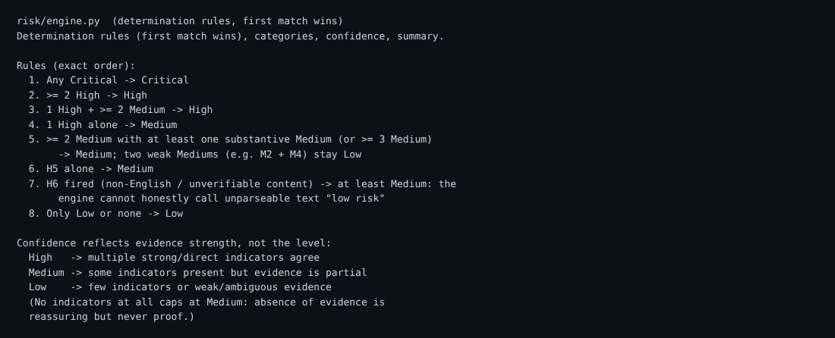
Source: risk/engine.py — Ordered rules guaranteeing Critical indicators always dominate; confidence reflects evidence strength rather than severity level.
Figure 2 — Analysis API Response (HIGH risk example with payment + sensitive data requests)
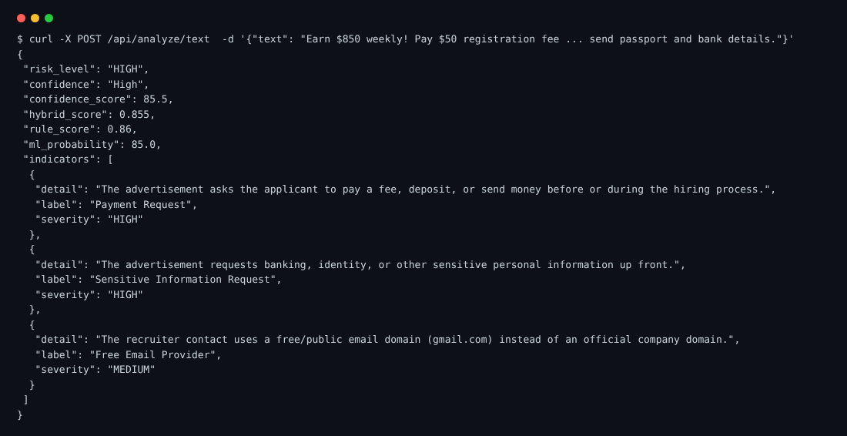
Live API endpoint /api/analyze/text returning structured risk_level, confidence, hybrid_score, rule_score, ml_probability and graded indicators. Demonstrates language discipline (objective detail text, never “this is a scam”).
Figure 3 — Risk Dashboard: Scanned jobs grouped by Critical / High / Medium / Low risk levels
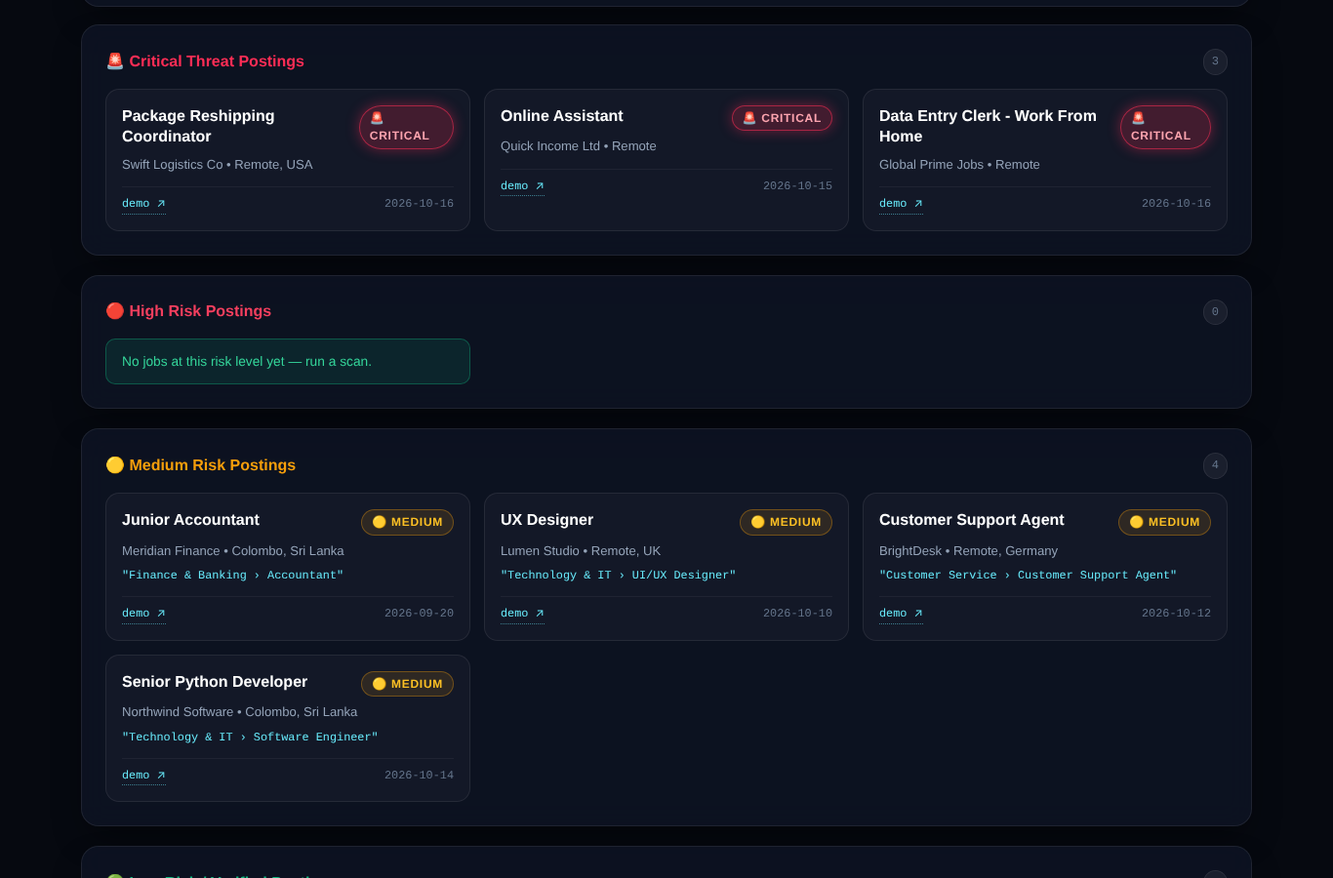
Dashboard view after multi-board scan. Jobs are automatically classified by the deterministic Risk Engine and presented with severity badges, company, location and taxonomy tags. Live demo: https://scam-sentry-1.onrender.com/dashboard

Figure 4 — Job Threat Dossier (full evidence report for a Critical posting)
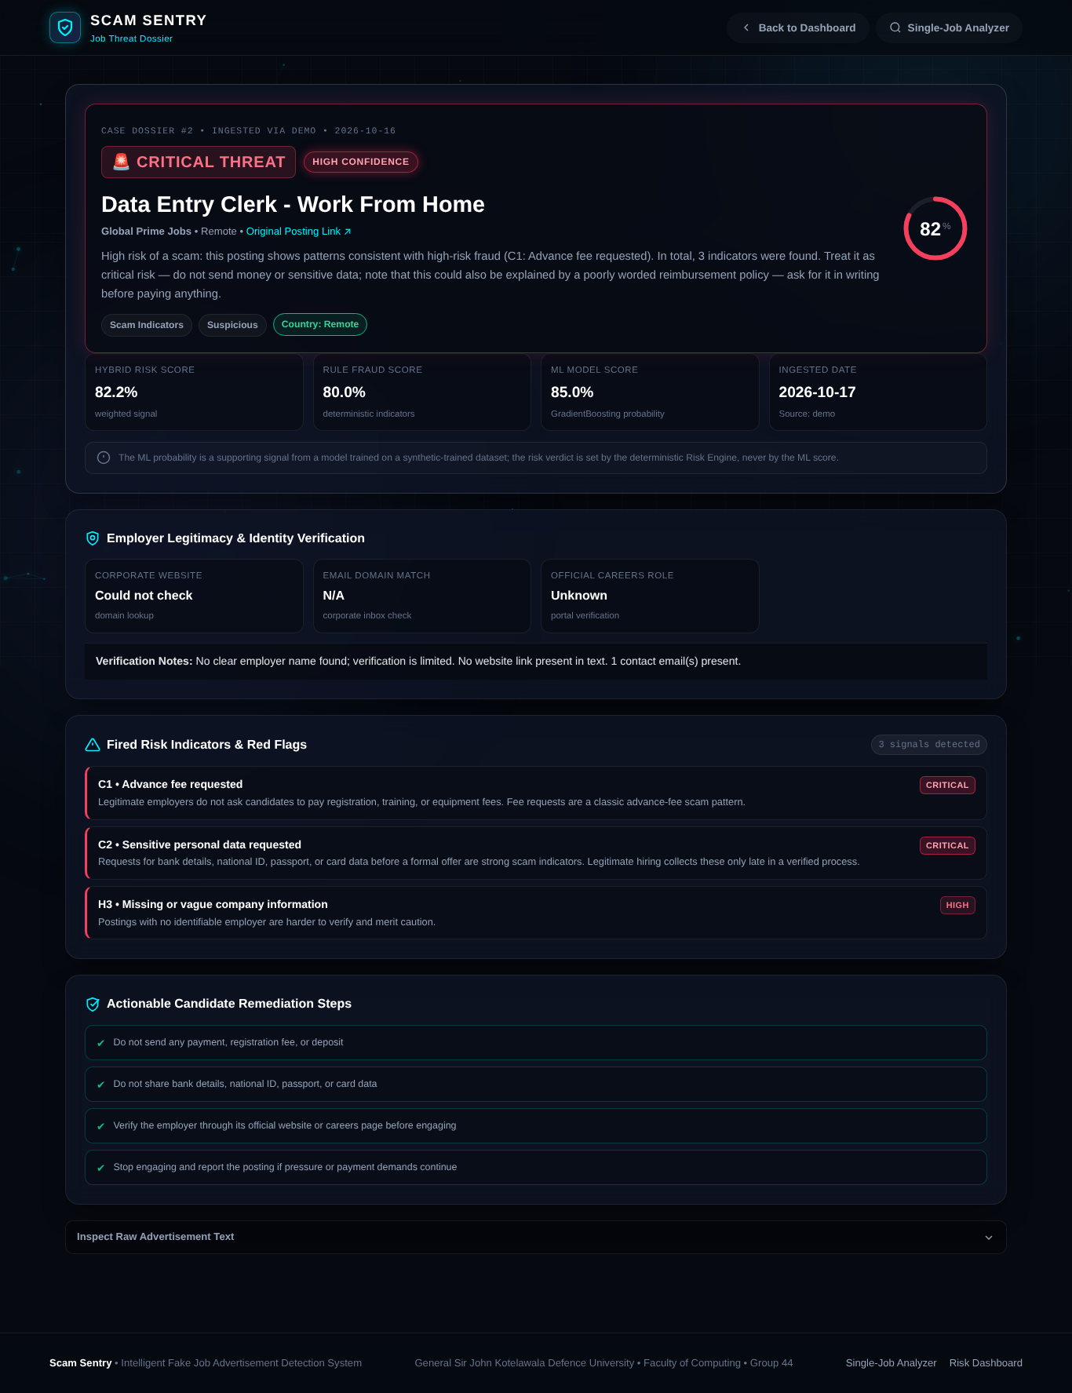
Complete dossier page showing hybrid risk score, rule fraud score, ML supporting signal (explicitly labelled as non-overriding), fired Critical/High indicators with forensic explanations, employer verification panel, and actionable candidate remediation steps. Note the language discipline: “High risk of a scam: this posting shows patterns consistent with…” rather than absolute accusations.
Figure 5 — Git commit history (Yasith Nirmal Peiris — 50 commits, >18,300 lines added)
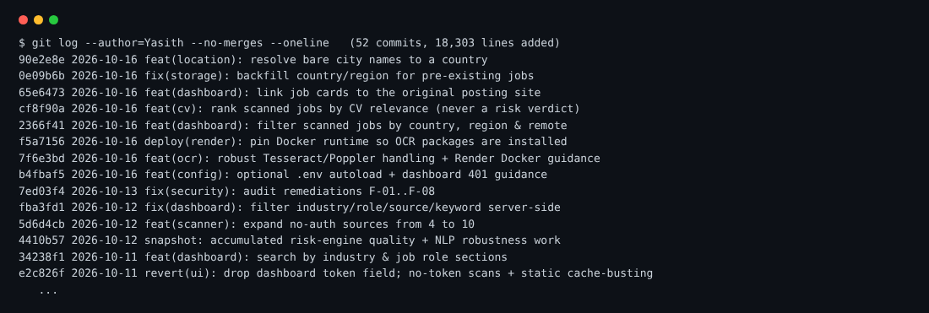
Excerpt of git log --author=Yasith showing feature commits for location normalisation, CV matcher, OCR, security audit remediations F-01..F-08, scanner expansion to 10 sources, and risk-engine quality work.
Figure 6 — Automated Test Suite Results (403 passed in 18.89 s)
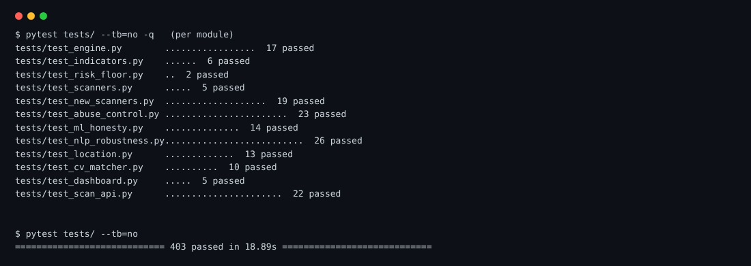
Full pytest run across 31 test modules covering risk engine, indicators, scanners, abuse control, ML honesty, NLP robustness, location, taxonomy, CV matcher, OCR, dashboard and scan API. Zero failures.

Summary of Tools, Frameworks & AI Techniques Used
• Programming & Frameworks: Python 3.11+, Flask 3.0, Flask-Limiter, Jinja2, Requests, Threading.
• Artificial Intelligence & NLP: Scikit-learn (GradientBoosting, TF-IDF Vectorizer, Cosine Similarity), Rule-based Expert Systems, Probability Calibration, Deterministic Regex Decision Trees.
• Database & Persistence: SQLite3, PostgreSQL (psycopg3), Database Schema Migrations, Repository Design Pattern.
• Quality Assurance & Security: Pytest (403 tests), GitHub Actions CI/CD, Pyflakes, API Token Authentication, CSP/OWASP Security Headers.
• Deployment & Infrastructure: Docker, Render Cloud PaaS, Tesseract OCR, Poppler Utilities, pdfplumber.
Key Individual Contribution Metrics
Total Git commits authored | 50 / 72 repository commits (69.4%)
Lines of code added | > 18,300 lines (Python, SQL, YAML, JS, HTML)
Automated tests authored | 403 tests across 31 modules — 100% pass rate
Job-board scanners implemented | 10 public sources (pluggable BaseScanner architecture)
Risk indicators designed | 18 graded indicators (C1–C4, H1–H6, M1–M5, L1–L3)
Live production deployment | https://scam-sentry-1.onrender.com/
Declaration
I confirm that the technical contributions, architectural designs, implementations, and test suites detailed above accurately and truthfully represent my individual work in Group 44 for the Scam Sentry project. I am prepared to demonstrate, defend, and explain all associated source code, algorithms, and technical artifacts during oral examination.
Student Signature: | ________________________ | Submission Date: | ____ / ____ / 2026
— End of Individual Contribution Sheet —

